Name of School:……………………………………………………………………………………………………

Candidate’s Name:…………………………………………………………………………………………………

Centre No./Index No: ………………………………………………………….… Signature:………………

**P530/1**

**BIOLOGY**

**Paper 1**

**July /August**

2 ½ Hours



**ELITE EXAMINATION BUREAU MOCK 2019**

**Uganda Advanced Certificate of Education**

BIOLOGY (THEORY)

**Paper 1**

2 Hours 30 minutes

**INSTRUCTIONS TO CANDIDATES**

* *This paper consists of sections* ***A*** *and* ***B****.*
* *Answer* ***all*** *questions in both sections*

**SECTION A**

*Answer to this section must be written in the boxes provided.*

**SECTION B**

*Answers to this section should be written in the spaces provided, and not anywhere else.*

*No additional sheets of paper should be inserted in this booklet.*

**Turn over**

|  |  |  |  |
| --- | --- | --- | --- |
| **For examiners’ Use Only** | | | |
| **Section** | | **Marks** | **Examiner’s signature & No.** |
| **A** | **1-40** |  |  |
| **B** | **41** |  |  |
| **42** |  |  |
| **43** |  |  |
| **44** |  |  |
| **45** |  |  |
| **46** |  |  |
| **TOTAL** |  |  |  |

**SECTION A (40 MARKS)**

*Write the letter corresponding to the right answer in the box provided. Each question in this section carries* ***one*** *mark.*

1. Which one of the following is the last organ to mature in man?

A. Gonad B. Brain

C. Motor organ D. Digestive tract

2. In meosis, crossing over occurs between;

A. Sister chromatids of homologous chromosomes

B. Non sister chromatids of homologous chromosomes

C. Sister chromatids of non-homologous chromosomes

D. Non homologous chromosomes

3. The following conditions are caused by non-chromosome disjunction except.

A. Turner’s syndrome

B. Trisomy 21

C. Klinefelter’s syndrome

D. Phenylketanuria (PKU)

4. Which one of the following combinations consists of essential amino acids only?

A. Phenylalanine and tyrosine

B. valine and Glutamine

C. Tryptophan and Histidine

D. Serine and tyrosine

5. A researcher wanted to establish the number of rats in a small garden near a university Hall and he obtained the following data.

Number of Rats in the first capture was 60 rats.

Number of rats in the second capture was 80rats

Number of organisms recaptured was 30rats

What was the population size of the rats in the garden?

A. 160 B. 80 C. 120 D. 60

6. Which of the following correctly explains why a cell which has started mitosis continues with the process up to completion when treated with a metabolic poison?

A. mitosis is unaffected by metabolic poisons.

B. replication of organelles has taken place already.

C. the cells become resistant to metabolic poisons and continue with normal processes.

D. The cell has built up a sufficiently large store of energy to carry the process through.

7. A polysaccharides consisting of parallel polysaccharide chains cross linked at regular intervals by short chains of amino acids is called

A. cellulose B. Chitin

C. Murein D. Hemicellulose

8. A given cell carries out transcription at a rate of 20 nucleotides per second and translation at a rate of 300 amino acids per second.

How long will it take for that cell to manufacture a protein which consists of 300 amino acids?

A. 15seconds transcription and 60 seconds translation.

B. 45 seconds transcription and 60 seconds translation.

C. 15 seconds transcription and 1500 seconds translation.

D. 100 seconds transcription and 20 seconds translation.

9. Which one of the following is not a function of plasmids.

A. confer resistance to antibotics.

B. confer resistance to disinfectants.

C. responsible for the fermentation of milk to cheese

D. small circles of DNA concerned with sexual reproduction

10. The correct arrangement of microtubules at the base of the flagella is

A. 9 + 2 B. 9 + 0

C. 8 + 0 D. 2 + 9

11. An actively photosynthesizing plant was supplied with water containing 18O isotope of oxygen. In which products of photosynthesis would this isotope be found?

A. Oxygen produced by chloroplast grana.

B. Oxygen produced by the chloroplast stroma.

C. carbohydrate produced by chloroplast grana.

D. carbohydrate produced by the chloroplast stroma

12. The following explains the use of alcohol as a sterilizing agent except;

A. Destroy the partial permeability of membranes

B. denature membrane proteins.

C. they dissolve lipids in the cell membrane

D. kill bacteria left on medical instruments

13. White blood cells are divided into granulocytes and agranulocytes. Which one of the following pairs consists of granulocytes and agranulcytes respectively?

A. macrophages and Basophills

B. Neutrophills and Basophills

C. Monocytes and Neutrophills

D. Eosinophills and lymphocytes

14. Which one of the following cells have a multi-lobed nucleus?

A. Neutrophils B. Eosinophils

C. Basophil D. lymphocytes

15. During inspiration in man

A. intercostal muscles contract

B. internal intercostal muscles contract while external intercostal muscles relax

C. External intercostal muscles contract

D. the ribs move inwards

16. The oxygen dissociation curve of two animals is shown in the graph below.

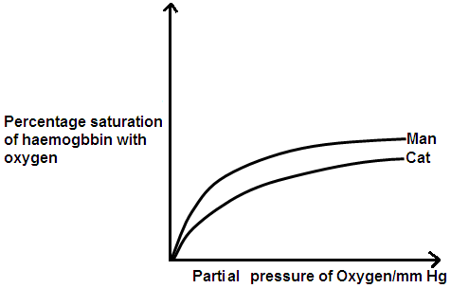

What conclusion can be made from the graph?

A. The Haemoglobin of the cat has a higher affinity for oxygen than that of man.

B. the metabolic rate of man is higher than that of the cat.

C. the haemoglobin of man has a higher affinity for oxygen than that of cat.

D. the cat can easily obtain oxygen from the environment compared to man.

17. The compound formed when carbon monoxide reacts with haemoglobin is called?

A. carboxyhaemoglobin

B. Carboaminohaemoglobin

C. carbondioxide – haemoglobin complex

D. oxyhaemoglobin

18. Which one of the following best explains how cytotoxic T-cells invade their opponents?

A. by opsonisation

B. By agglutination

C. punching holes through cell surface membranes

D. by neutralization and lysis

19. One of the following pairs consists of living cells only. Point it out

A. companion cells and sieve tube cells

B. xylem vessels and companion cells

C. Tracheids and sieve tube cells

D. Transfer cells and Xylem vessels

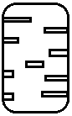20. The diagram in figure I below shows type of thickening in xylem vessels which one is it

A. multiple spiral thinking

B. reticulate thickening

C. Spiral thickening

D. multiple thickening

21. During gastrulation, each of the three layers of the gastulla forms different tissues, systems and organs. Which one of the following pairs come from the ectoderm?

A. Vertebrae and spinal cord

B. sense organs and Brain

C. Dermis and muscles

D. sex organs and muscles

22. The following are roles of progesterone during pregnancy except.

A. initiates urine contractions during labour

B. inhibits uterine contractions

C. causes growth of mammary glands

D. inhibits activities of oxytocin and prolactin

23. Which one of the following mammals mate face to face

A. gorillas and elephants

B. whales and pigs

C. Humans and orang –utans

D. Chimpanzees and monkeys

24. Figure 2 below describes the pattern of growth of many populations and individual organs. Which one of the regions labelled shows growth at its maximum.

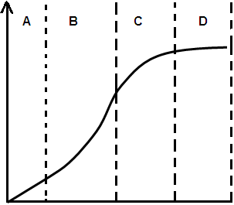

25. In some organisms, the organs appear to grow at the same rate as the rest of the body. The organisms which grow in this way include:

A. insects and birds

B. Birds and fish

C. fish and butterflies

D. fish and locusts

26. Lactation depends on the action of hormones which include

A. progresterone and oestrogen

B. oxytocin and prolactin

C. prolactin and oestrogen

D. prolactin only

27. Which one of the following pairs consists of perennating organs only?

A. stem tubers and Rhizomes

B. stolons and suckers

C. corms and runners

D. bulbs and suckers

28. Which one of the following plant growth substances is produced in conditions of drought.

A. Abscisic acid

B. cytokinin

C. Gibberellins

D. Auxins

29. Flowering is a phytochrome controlled response. Which one of the following promotes flowering in tobacco.

A. low concentration of Pr

B. high concentration Pr

C. low concentration of Pfr

D. high concentration of Pfr

30. Which one of the following combinations consists of pourched mammals only.

1. rhea 2. Turtles 3. Shrew 4. Tasmania wolf 5. Opossum 6. Koala bear 7. Kangaroo

A. 1,2,4,7only B. 2,4,5,6,7 only

C. 2,4,5,6,7 only D. 4,5,6,7 only

31. The phylum of the animal kingdom made up of sessile organism whose system of cavities inside is open to the outside by pores is

A. phylum coelenterate

B. phylum protozoa

C. phylum porifera

D. phylum Nemertinea

32. How do we call characteristics whose genes are carried on a chromosome which carries the Tfm gene.

A. sex linked traits .

B. Holandric characteristics.

C. pleitropic characteristic.

D. recombinant characteristic.

33. Which one of the following describes endonucleases?

A. enzymes which cut DNA at specific points.

B. enzymes bring about DNA profiling.

C. enzymes which remove exons.

D. enzymes which remove super coils in DNA.

34. Which of the following occurs when the dorsoventral muscles of the thorax contract?

A. tergal attachment of the wing moves upwards relative to the pleural attachment.

B. the wing goes down

C. tergal attachment of the wing moves down wards relative to pleural attachment

D. The pleural attachment moves downwards relative to the tergal wing attachment.

35. Several groups of muscles are involved in movement in tetrapods. Which one of the following muscles are the most important in propelling the body forward?

A. protractors and Adductors

B. extensors and protractors

C. Flexors and Abductors

D. extensors and retractors.

36. Which one of the following makes the octopus’s brain an ideal animal for studying the effect of removing certain parts of the brain on memory?

A. octopus animals are readily available

B. octopuses can easily be kept in laboratory situations

C. octopus have large brain size and high ability to withstand surgery

D. octopus have a vertical lobe of the brain which can easily be removed.

37. Which one of the following forms of learning enables organisms to avoid trivial irrelevant stimuli and young organisms to identify with their parents respectively.

A. explaratory learning and insight learning

B. Habituation and imprinting respectively

C. imprinting and habituation respectively

D. Habituation and insight learning

38. What type of location results from 80% of forward thrust in fish being obtained from side to side lashing of the tail and caudal fin in fish?

A. anguilliform locomotion

B. carangiform locomotion

C. ostraciform locomotion

D. Branchiation locomotion

39. Which one of the following forms of dormancy is **not** seasonal?

A. Diapause B. Aestiation

C. Seed dormancy D. Hibernation

40. The nitrogen cycle involves nitrogen fixation whichis carried out by:

A. Rhizobium and azotobacter

B. Clostridium and nitrosomonas.

C. Nitrobacter and azotobacter.

D. Rhizobium and nitrosomonas

**SECTION B (60MARKS)**

41. a) In maize the genes for coloured seed and full seed are dominant to the genes for colourless seed and shrunken seed. Using suitable genetic symbols, show the offsprings and phenotypic ratio of the test cross of the F1 generation if the two genes are linked. (7marks)

……………………………………………………………………………………………………………………………………………………………………………………………………………………………………………………………………………………………………………………………………………………………………………………………………………………………….………………………………………………………………………………………………………………………………………………………………………………………………………………………………………………………………………………………………………………………………………………………………………………………………………………………………………………………………………………………………………………………………………………………………………………………………………………………………………………………………………………………………………………………………………………………………………………………………………………………………………………………………………………………………………………………………………………………………………………………………………………………………

b) It was however observed that the above cross produced the following results

coloured, full seed 380

colourless, shrunken seed 396

coloured, shrunken seed 14

colourless, full seed 10

calculate the distance in units between the genes for coloured seed and seed shape on the chromsomes (3marks)

……………………………………………………………………………………………………………………………………………………………………………………………………………………………………………………………………………………………………………………………………………………………….

…………………………………………………………………………………………………………………….

42. Samples of 10cm3 of stomach contents of a normal person were removed when a meal was given and at half-hour intervals thereafter. The graph shows the volume of a 0.1 moldm-3 solution of sodium hydroxide needed to neutralize the acid in the samples.

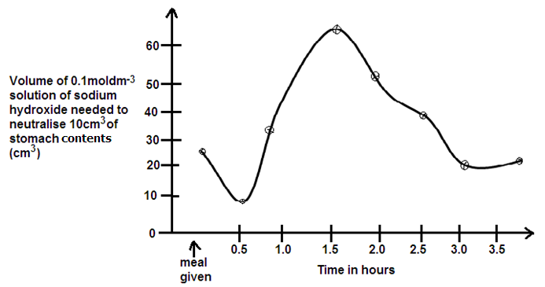

a) Explain the variations of the acidity of the stomach contents shown in the graph above. (6marks)

………………………………………………………………………………………………………………………………………………………………………………………………………………………………………………………………………………………………………………………………………………………………

……………………………………………………………………………………………………………………………………………………………………………………………………………………………………………………………………………………………………………………………………………………………………………………………………………………………………………………………………………………………………………………………………………………………………………………………………………………………………………………………………………………………………………………………..

b) Describe the various mechanisms responsible for the increase in acid secretion shortly after a meal. (4marks)

………………………………………………………………………………………………………………………………………………………………………………………………………………………………………………………………………………………………………………………………………………………………

………………………………………………………………………………………………………………………………………………………………………………………………………………………………………………………………………………………………………………………………………………………………43. a) Define the term target cell. (1mark)

……………………………………………………………………………………………………………………………………………………………………………………………………………………………………………………………………………………………………………………………………………………………… b(i) State three differences between plant hormones and animal hormones.

……………………………………………………………………………………………………………………………………………………………………………………………………………………………………………………………………………………………………………………………………………………………….…………………………………………………………………………………………………………………………………………………………………………………………………………………………………………

(ii) Describe how adrenalin exerts its effects on target cells. (7marks)

………………………………………………………………………………………………………………………………………………………………………………………………………………………………………………………………………………………………………………………………………………………………………………………………………………………………………………………………………………………………………………………………………………………………………………………………………………………………………………………………………………………………………………………………………………………………………………………………………………………………………………………………………………………………………………………………………………………………………………………………………………………………………………………………………………………………………………………………………………………………………………………………………………………………………………………………………………………………………………………………………

44. a) State the five major processes from which unwanted substances are derived from in bodies of organisms. (2 ½ marks)

…………………………………………………………………………………………………………………………………………………………………………………………………………………………………………………………………………………………………………………………………………………………………………………………………………………………………………………………………………………………………………………………………………………………………………………………………………

b(i) Define the term Euryhaline fish. (1mark)

……………………………………………………………………………………………………………………………………………………………………………………………………………………………………………………………………………………………………………………………………………………………..

(ii) Explain how euryhaline fish are able to solve their Osmoregulatory problems. (5marks)

……………………………………………………………………………………………………………………………………………………………………………………………………………………………………………………………………………………………………………………………………………………………………………………………………………………………………………………………………………………………………………………………………………………………………………………………………………………………………………………………………………………………………………………………………………………………………………………………………………………………………………………………………………………………………………………………………………………………………………………………………………………………………………………………………………………………………………………………………………………………………………………………………………………

(iii) State the ecological advantage of eryhaline fish over marine teleosts.

(1 ½ marks)

…………………………………………………………………………………………………………………………………………………………………………………………………………………………………………………………………………………………………………………………………………………………………………………………………………………………………………………………………………………..

45. a) Define the term industrial melanism? (1mark)

…………………………………………………………………………………………………………………………………………………………………………………………………………………………………………………………………………………………………………………………………………………………………………………………………………………………………………………………………………………..

b) The peppered moth, *Biston betularia*, produces a black variety from time to the time. The mutation causing this black variety results in a dominant allele, B. The black variety was first observed in 1848 in Manchester, but by 1895, it had increased to 95% of the population in the city.

(i) What was the frequency of the dominant allele, B in the 1895 population of the moth? Show your working. (3marks)

…………………………………………………………………………………………………………………………………………………………………………………………………………………………………………………………………………………………………………………………………………………………………………………………………………………………………………………………………………………………………………………………………………………………………………………………………………

(ii) What was the population size of the non- black variety in 1895 if the total population of moths in Manchester was 1000? (2marks)

…………………………………………………………………………………………………………………………………………………………………………………………………………………………………………………………………………………………………………………………………………………………………………………………………………………………………………………………………………………………………………………………………………………………………………………………………………

c) With examples, explain the following terms

i) Analogous structures. (2marks)

…………………………………………………………………………………………………………………………………………………………………………………………………………………………………………………………………………………………………………………………………………………………………………………………………………………………………………………………………………………………………………………………………………………………………………………………………………

ii) Vestigial structures (2marks)

……………………………………………………………………………………………………………………………………………………………………………………………………………………………………………………………………………………………………………………………………………………………….…………………………………………………………………………………………………………………………………………………………………………………………………………………………………………

46. The figure below represents the main stages of aerobic respiration.

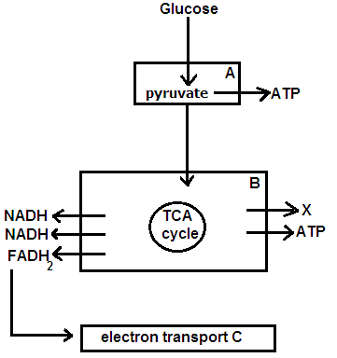

(i) State precisely where the reactions in boxes A,B and C occur in the cell. (3marks)

A ………………………………………………………………………………

B ………………………………………………………………………………

C ………………………………………………………………………………

(ii) State how many ATP molecules are formed at each stage. (1 ½ marks)

A ………………………………………………………………………………

B ………………………………………………………………………………

C ………………………………………………………………………………

b(i) Briefly describe the fate of pyruvate in the absence of oxygen in animals. (3marks)

…………………………………………………………………………………………………………………………………………………………………………………………………………………………………………………………………………………………………………………………………………………………………………………………………………………………………………………………………………………………………………………………………………………………………

(ii) State the precise role of oxygen in cellular respiration. (2 ½ marks)

……………………………………………………………………………………………………………………………………………………………………………………………………………………………………………………………………………………………………………………………………………………………………………………………………………………………………………………

**END**